<https://www.studytonight.com/java/nested-classes>

A class defined within another class is known as Nested class. The scope of the nested class is bounded by the scope of its enclosing class.

i.e

if you create instance of inner class in outer class. Then you can access the private methods of inner class.

You can not access the private methods of inner class if you create the instance other than inner or outer class.

class Outer{

//class Outer members

class Inner{

//class Inner members

}

} //closing of class Outer

**Advantages of Nested Class**

1. It is a way of logically grouping classes that are only used in one place.
2. It increases encapsulation.
3. It can lead to more readable and maintainable code.

If you want to create a class which is to be used only by the enclos

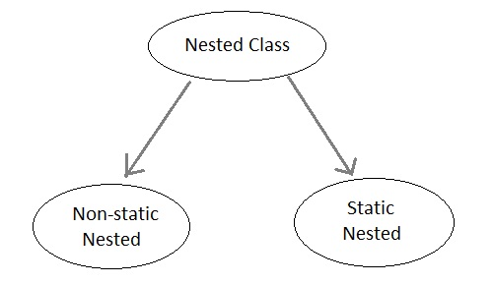w

#### Static Nested Class

If the nested class i.e the class defined within another class, has static modifier applied in it, then it is called as **static nested class**. Since it is, static nested classes can access only static members of its outer class i.e it cannot refer to non-static members of its enclosing class directly. Because of this restriction, static nested class is rarely used.

#### Non-static Nested class

Non-static Nested class is the most important type of nested class. It is also known as **Inner class**. It has access to all variables and methods of Outer class including its private data members and methods and may refer to them directly. But the reverse is not true, that is, Outer class cannot directly access members of Inner class. Inner class can be declared private, public, protected, or with default access whereas an Outer class can have only public or default access.

One more important thing to notice about an Inner class is that it can be created only within the scope of Outer class. Java compiler generates an error if any code outside Outer class attempts to instantiate Inner class directly

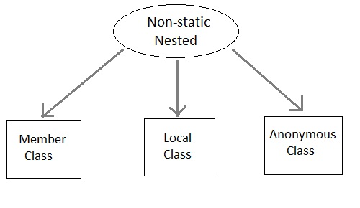

A non-static Nested class that is created outside a method is called **Member inner class**.

#### Example of Inner class(Member class)

class Outer

{

public void display()

{

Inner in=new Inner();

in.show();

}

class Inner

{

public void show()

{

System.out.println("Inside inner");

}

}

}

class Test

{

public static void main(String[] args)

{

Outer ot=new Outer();

ot.display();

}

}

Output:Inside inner

A non-static Nested class that is created inside a method is called **local inner class**. If you want to invoke the methods of local inner class, you must instantiate this class inside the method. We cannot use private, public or protected access modifiers with local inner class. Only abstract and final modifiers are allowed.

#### Example of Inner class inside a method(local inner class)

class Outer

{

int count;

public void display()

{

for(int i=0;i<5;i++)

{

class Inner <font color="green">//Inner class defined inside for loop</font>

{

public void show()

{

System.out.println("Inside inner "+(count++));

}

}

Inner in=new Inner();

in.show();

}

}

}

class Test

{

public static void main(String[] args)

{

Outer ot=new Outer();

ot.display();

}

}

Inside inner 0

Inside inner 1

Inside inner 2

Inside inner 3

Inside inner 4